Reforestation Policy Paper 2010

The Growing CO₂ Crisis
Carbon Dioxide (CO₂) traps infrared energy from the sun; heating up our planet in a phenomenon known as the green house effect, and contributing to global warming. Oxygen (O₂) levels are falling in a measureable decrease. Meanwhile, mankind's impact on CO₂ levels continues to grow:
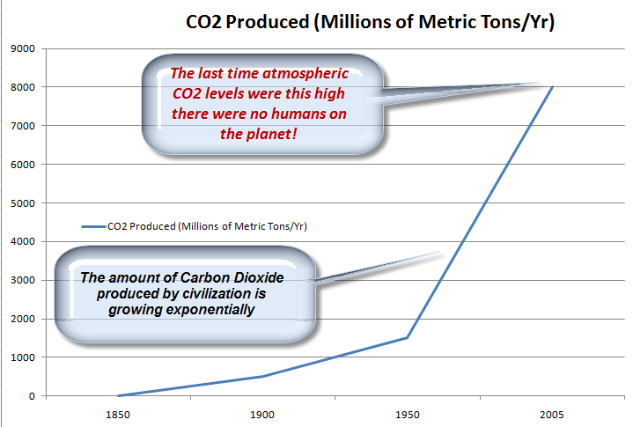

Alternatives in Addressing The Problem
There are 2 general ways we can reduce atmospheric CO₂ : Carbon Sequestration, Collection & Storage; and Reforestation.

Carbon Sequestration, Collection & Storage (CCS)
It may be surprising to learn that nearly 40 percent of the CO₂ produced by the U.S. comes from power plants. Reducing greenhouse gases pouring into the atmosphere from coal and oil plants is thus a priority and it is understandable to think in terms of reducing this amount by capturing it before it is released into the air. In a CCS approach, CO² from power plants is converted into tangible form and stored offsite; for example underneath a mountain as if it were nuclear waste. Although experimental CCS equipped power plants have been in place since the 1980's, such installations are very expensive. Other disadvantages of CCS include:
- Capturing, transporting and storing CO₂ requires more energy consumption; which in turn produces more CO².
- Installing and operating CCS will reduce the profitability plant operators and power companies.
- CCS will introduce more regulatory oversight: it must be supported by a Cap and Trade policy together with inspections and deterrents to function.
- CCS does not harness the free market to spur innovation in new energy technologies.
- CO₂ stored via CCS can still leak back into the atmosphere (e.g. due to seismic activity, accidents, erosion).

Reforestation
In a reforestation strategy we assist to reduce excess CO₂. The world's forests have sequestered an estimated 430 billion metric tons of carbon from CO₂. This is more carbon than will be released by fossil fuel burning over the next 70 years . Even today, American forests sequester an estimated 10% of the CO₂ produced annually by the U.S.; not to mention additional amounts captured by trees or plants that are not part of forests. Although older forests play a greater role in carbon storage, young forests will sequester CO₂ at a greater rate.
- The next few years will likely be overshadowed by a financial crisis very likely to eclipse funding on dealing with Climate Change. For this reason alone an immediate, extensive and inexpensive approach must be found. That approach is reforestation and afforestation (conversion of non-forest land) on a large scale. During our Great Recession, reforestation can employ people in a public works program (e.g. the Environmental Defense Corps) while forests sequester CO₂ and increase levels of atmospheric oxygen, for free. This strategy would also increase our own natural resources while leading the World away from the perils of deforestation. A cohesive US reforestation policy:
- Gives America a lead by example position as to what other countries should and should not do with their own trees
- Sets up for both present and future generations a natural Carbon Sequestration program.
- Maintains species preservation and other environmental objectives.
- Keep the U.S. in line with other reforesting nations such as China; and secures a leadership position.

The U.S. & Americans Can Lead The Way
Cap and Trade, Carbons Sequestration and Nuclear Power are all important weapons in the battle against greenhouse gases but this is a battle, at this moment, we have lost. CO₂ levels in the atmosphere will continue to grow even if we maintain the world's forests as they are today. Even if levels of greenhouse gases were frozen at today's levels the Greenland and Arctic Ice caps will still melt and the loss of albedo (the ability of ice to reflect energy back into space) will further increase temperatures. In short: we must reforest; and the U.S. can lead the way. U.S. forests represent 5% of the world's forests and an increase can be effected through both the public and private sectors. There are numerous vehicles for engaging Americans in reforestation:
- The Forest Service is established and effective.
- A reforestation project lends itself well to volunteerism under the Environmental Defense Corps.
The project could become beneficial to the economy as a funded job creation Public Works Project.
- Ted Turner has a reforestation program on his 2 million acres of land. Mr. Turner and other high profile figures could be enlisted to inspire Americans to participate in their local communities.
- The United States has a vast land area with much potential for reforestation not only in marginal land, but crop land through Agro forestry and, most importantly, urban and suburban areas with the redesign of arboreal landscaping.
  - Even the nation's Capital, situated in a forested region of the country, has room for trees everywhere and, as an example; Virginia has adopted a proactive approach to development by requiring that at least 10 percent of the land in any development must be kept in its original state.

A reforestation approach must be formulated now in a country where primary forests once covered nearly half the land.
Gary S. Schofield
Lars P. Hanson
Henry A. Perretta

The Global Concern, Inc
www.TheGlobalConcern.org

Professor Haymet, Scripps Institution of Oceanography, Georgetown University Inaugural Lecture on Global Climate Change 2008
Dixon et al. 1994
State of Americas Forests, Mila Alvarez, 2007
Agro forestry is an agricultural approach of using the interactive benefits from combining trees and shrubs with crops and/or livestock

